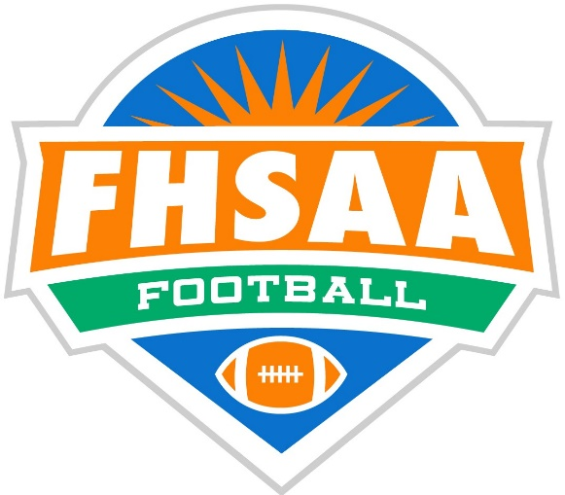
2023
Miracle Strip Officials Association Pre-Game

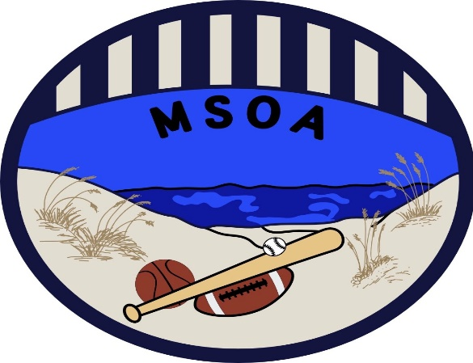
msoasports@yahoo.com
www.msoasports.com
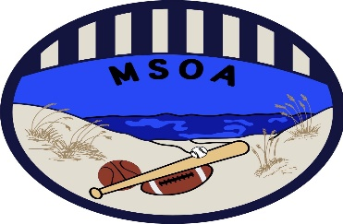

2023 Miracle Strip Pre-Game
TIMING
Referee Check Time with BJ and ECO
ALL need the same time
Discuss w/ ECO what time Clock should go 0:00
Quarter & Half Lengths
Middle is 9 Minute Quarters / 10/15 min half
JV/9th Decided by HOME Coach - not our job
Varsity 12 Minute Quarters / Half is 17 plus 3
Start 17 on Referee Signal/ Start 3 after 17
DO NOT let horn sound if Band is playing!!

Overtime Procedures
Soon as 4Q expires ECO puts 3 minutes on clock
Additional OT periods is 1 minute on clock

25 / 40 Sec Clock Operations
Last 2 minutes of both 2/4 Quarter Offended Team
Single Pump is reset the 25
Double Pump is reset the 40
Crew enters Field AT LEAST 30 mins prior to Kickoff

2023 NFHS RULE CHANGES
Clarified That Towels Do Not Have to Be The Same Solid Color For Each Player [1-5-3a(5)a 4, 5 (NEW)]: Player towels may contain one manufacturer’s logo and/or one school logo neither exceeding 2¼ square inches. Towels must be a solid color but now do not have to be the same solid color for each player. Towels may not be ball- or penalty-flag colored.
Clarified When A Player Is Inbounds After Being Out of Bounds [2-29-1]: This change clarifies when a player is inbounds after being out of bounds. There is no change to any foul or subsequent penalty provisions, or any rules related to illegal participation or the provisions regarding eligibility to catch a pass.
Added A List Of Criteria To Help Identify Players Who Should Be Defined As Defenseless Receivers [2-32-16d, 9-4-3g]: This change adds to the list of criteria to help identify players who should be defined as defenseless receivers related to application of unnecessary or excessive contact. This clarification should help game officials and coaches by defining allowable contact against defenseless receivers.
Intentional Grounding Exception Changed [7-5-2 EXCEPTION 2a, c (NEW)]: This change permits the exception for intentional grounding to the first and only player to possess the ball after the snap ends.
Removed “Intentional” From Pass Interference in TABLE 7-5 [TABLE 7-5(2)c (DELETE), 7-5 PENALTY]: By removing “intentional” from pass interference, this change puts the rule in line with how it is already enforced which is a 15-yard penalty.
Changes In Basic Spot Penalty Enforcement [10-4, 6]: This change restructures and clarifies the amendments to Rule 10 to eliminate the excessive penalty enforcements for offensive fouls that occur behind the line of scrimmage. This revision stipulates the basic spot for enforcement of fouls behind the line of scrimmage is the previous spot rather than the spot of the foul. Current penalties for illegal kicking, batting and participation fouls, and provisions for offensive fouls occurring in the end zone that may result in a safety remain intact.
2023 POINTS OF EMPHASIS
- Helping the Runner
- Communication Between Coaches and Game Officials
- Game Management
2022 NFHS RULE CHANGES---REHASH!!
1-2-3g NOTES 3. (NEW): Team Box May Be Extended by State Association Adoption
By state association adoption, the team box may now be extended beyond the 25-yard line. (FHSAA is 25 to 25)
1-3-3: Ball May Be Changed Between Downs
Any game official may order the ball changed between downs.
1-4-3: The Number “0” Is Now Legal
The single digit number “0” is now a legal number. The number “00” is NOT legal
2-3-8: A Chop Block Has Been Redefined
A chop block has been redefined as an illegal combination block where contact is made above and below the waist.
3-4-7: Clarified: Offended Team’s Game Clock Options Clarified When a foul is committed with less than 2 minutes remaining in either half, the offended team will have the option to start the game clock on the snap
3-6-1a(1)e EXCEPTION 2. (NEW): Added A New Exception to The Play Clock Administration
Added a new exception to the play clock administration following a foul committed only by the defensive team.
7-5-2 EXCEPTION 2. (NEW): New Exception for The Passer
Added a new exception that allows the passer to legally throw the ball away to conserve yardage.

2022 EDITORIAL CHANGES
2-28-2; 5-2-4; 6-2-6; 10-2-2; 10-2-3;
FOOTBALL FUNDAMENTALS – VII-2, X-3-E;
RESOLVING TIED GAMES – 5-1-1, 8-3;
2022 POINTS OF EMPHASIS
- Sportsmanship
- Targeting / Defenseless Player
- Legal Uniforms and Equipment

2021 RULE CHANGES---REHASH!!!
Action in the Free-Blocking Zone
[2-17-2c (NEW), 2-17-4]
Blocking below the waist now requires the block to begin immediately following the snap.

- POINTS OF EMPHASIS
- Sportsmanship
- Intentional Grounding
- Ineligible Downfield/Line of Scrimmage Formation

Do you see the SAME #1… things that make you say HMMMMMMMMMMMMMMMM!!

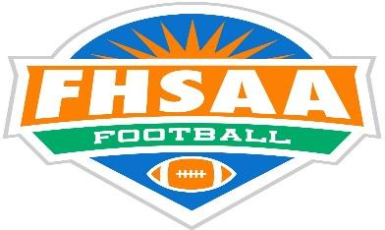
PRE-GAME DUTIES
All- Walk the Field looking for Safety concerns
Ref/Ump- Coaches Mtg with assigned HL or LJ
HL/LJ- Check Chains, Meet Chain Crew, Check Game Balls (Air), Brief Ball Boys on BOTH teams
BJ- Pylons/Goal Post Pads, Keep middle field OPEN,
Check with Band/ROTC/Dance Team on times
ALL- Check Teams for Illegal Equipment
COIN TOSS
Ref- Back to Scoreboard with speaking Captain
Ump- Opposite R – Speaking Captain on far end
HL- Ump side unless you need to brief Chains
LJ- with Ref (ensure BOTH ball boys present)
BJ On Ump side
LJ & HL may need to go get Captains 2 mins prior
to toss, BJ find teams if HL still briefing Chains
FREE KICKS
Positions:
R- @ Goal line opposite press box, Count R
U- R’s 20 yd on Press Box side, Count R
HL- R’s 30 opposite press box, Count R
LJ- R’s Free kick line (50) Count K & R
BJ- K Free kick line (40) Opposite press box Count K

ALL- After Counts, raise hand up waiting for Ref
Bean Bags in hand Look for Possible First Touching
Illegal Blocks/ K initiating before 10yds
Who CAN Advance -- Who CANNOT Advance?
Momentum Rule / Muff into endzone (Referee resp)
Possible Onside Kicks Spots Also Pop-up Kicks

PRE-SNAP DUTIES
REFEREEE & UMPIRE Count A
HEAD LINESMAN Count B/Confirm w/ BJ,
Confirm Wideouts
LINE JUDGE Count B /Confirm w/ BJ
Confirm Wideouts
BACK JUDGE Count B with HL / LJ
25/40 Second Clock
9/JV/MS ON FIELD
VARSITY PLAY CLOCK

RUNNING PLAYS
Watch for fouls at point of attack
Illegal blocks (Blocking below waist when not in Free Blocking Zone)
Keep plays boxed in
Award Forward progress earned
Wings square off spots raise hand to start 40 & hold until Ump releases
Dead Ball officiate for out of bounds plays
PASSING PLAYS
Wings know when to release and your KEYS
Who is Eligible/Ineligible?
(Wide out covering Tight End)?
Ineligible Receiver Downfield
Was pass caught behind neutral zone? (HL & LJ)
Intentional grounding (Ref w HL/LJ help)
Passer outside the free-blocking zone?
Pass reaches the neutral zone?

PASSES in ENDZONE
LJ/HL and BJ Decide who has catch, who has feet
Make eye contact and use up/down head motion (YES) or side/side head motion (NO).

SCORING PLAYS
Signal TD, straddling Goal line, NOT while running
If play is up middle, Wing’s crash until they find Ump
Ump gives you “Head Nod”; CRASH, Stop, signal TD
If no TD still crash, come in hard and SELL next Down
SCRIMMAGE KICKS
Formation & Numbering (Ref & Ump)
Fair Catch (Legal vs Illegal- Signaling) BJ
Who can advance? Who can ONLY recover?
LJ (release at snap)
HL (release after ball crosses neutral zone)
Ref- IF inside 20 think about keeping both wings home

PSK (Important for penalty enforcement)
- Foul by R

- Not on Try or successful Field Goal

- During scrimmage kick play that crosses NZ

- Before End of Kick

- R has possession when kick Ends

NOTE: ALL 5 CONDITIONS MUST BE MET FOR PSK ENFORCEMENTTO BE IN EFFECT!

MEASUREMENTS
Ref-Come in -- decide if 1st down or not
IF 1st down NOT gained give next down #
Signal Time Out if Measurement is needed
Motion for Chains- only move as fast as they can
HL- Move Box to front Stake
Make sure clip is in correct spot and bring Chain Crew out carrying clip locked into chains
BJ- Tend Ball
Butt down field
Align LJ to make sure we have a parallel chain pull
LJ- Go to yard line with the clip (look at HL)
Look at BJ for alignment
Hold clip w/foot once HL places clip on ground
U- Take front stake and pull gently
Ref- IF 1st down give signal send chains to sidelines
HL- RESET Chains
If not 1st down use chains to spot ball on nearest Inbounds spot if ball is in side zone, or leave where it lays. IF 4th down and 1st not made give 1st down Signal for going opposite direction

CHANGE OF QUARTER
HL- Record Down
Distance to go
Ball On -- Clip On
Confer w/Ref and Ump for same
Ref/Ump- Record Down
Distance to go Ball on ___
BJ- Secure Down Box and escort Holder to New Spot
LJ- Go to new Spot. Ensure Chains are on correct spot

PENALTIES
You can use radio BUT COME OFF sideline to R when reporting
Report who (color/team), what (foul), and player #
When (live or dead ball) Know status of ball
HL walk off penalty w/Ump to ensure correct
LJ hold enforcement spot and then verify
Be CALM, get it right…Clock is stopped
Ref and Ump agree on enforcement
Ref & Ump agree on Half distance enforcements

LOOSE ENDS
Record ALL Time outs (keep coaches informed)
BJ announce to crew how many TO left both teams
Bean bag all Fumbles
5 yd line going in (Go to Goal line officiate in)
5 yd line going out (Go to Goal line officiate out)
All officials record #’s on Unsportsmanlike Fouls

NO INADVERTENT WHISTLES!!
SEE the Ball,
SEE the Ball down,
SEE the Ball in possession…
CONFERENCES/TIME OUTS
Know where coaches need to be and keep them there!
During Time outs HL/LJ bring water to R/U/BJ
BJ times 60 sec- sounds whistle with 15 sec remaining (2 tweets)
ALL begin moving your teams back to field on tweets!

CREW EQUIPMENT CHECK
ALL DOUBLE CHECK EACH OTHERS EQUIPMENT
2 Flags, Whistle, Crew Bean Bag (matching),
ADDITIONAL ALTERNATE COLOR for BJ, LJ, HL
Game Cards/Pencil, Watch, RADIO
25/40 Timer for BJ
Coin for Ref
Chain Clip for HL
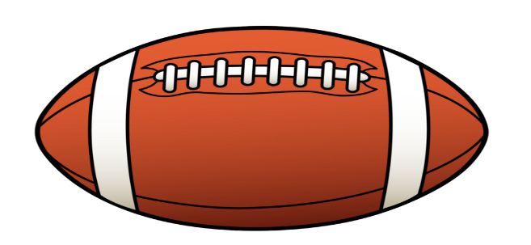

POST GAME
ALL NEED TO PARTICIPATE!
Criticize with purpose and /recommendations
Have thick skin & learn! -NO EXCUSES

REFEREE RESPONSIBILITIES
Submit Game Report on Arbiter within 24 hours
Submit Varsity Penalty Sheet to Assigner immediately upon completion of game to Assigner
Call Assigner immediately on Major Issues NOW!

Notes:

Contracted High School Coaches List
Tate - Rhett Summerford AD Greg Blackmon
Pace - Kent Smith AD Charlie Warner
Gulf Breeze– Jeff Gierke AD Matt Alt
Milton – Kelly Gillis AD George Blake
Navarre – Jay Walls AD Scott Murphy
FWB- Bobby Clayton AD Holly McDaniel
Choctaw – Frank Beasley AD Andy Thigpen
Niceville – Grant Thompson AD Daniel Griffin
Crestview – Thomas Grant AD Tim Hatten

Okaloosa Middle Schools
Davidson – Chris Small
Shoal River – Ryan Gillis
Ruckel – Ron Reece
Lewis – Joseph Pearson
Meigs – Josh Riggins
Pryor – Justin Savage
Bruner – Coach Seagar
Destin- Mark Hinterthan

