2023 MSOA Area Football Coaches
No matter how long you have been here or what level you officiate or what position you work you NEED to know everyone on this list and if you do not know them by site you get an OLD guy to point them out the first time you arrive at School X!!! Coach is NOT their name anymore then Ref is yours or Hump’s favorite “Hey Blue”!!!
Varsity Head Coach Athletic Director
Crestview Thomas Grant Tim Hatten
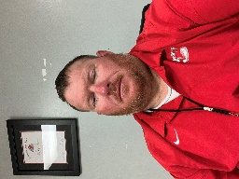
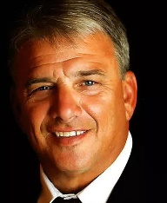

Niceville Grant Thompson Daniel Griffin
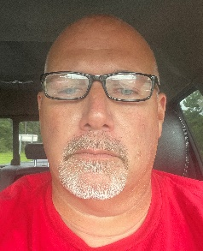
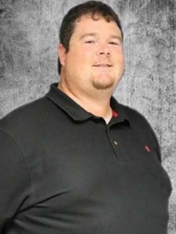

Choctaw Frank Beasley Andy Thigpen
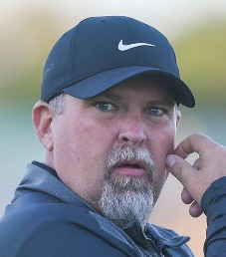
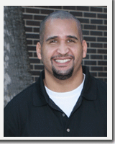

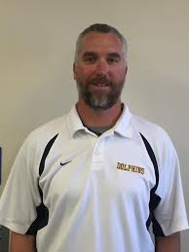
FWB Bobby Clayton Holly McDaniel
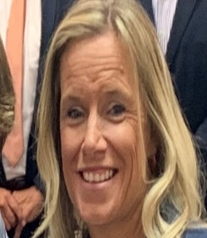

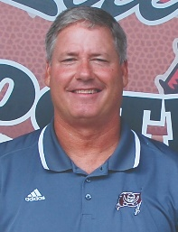
Navarre Jay Walls Scott Murphy

Gulf Breeze Jeff Gierke Matt Alt

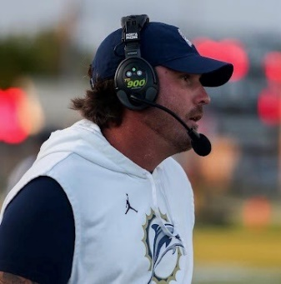
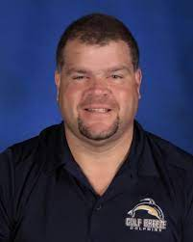

Pace Kent Smith Charlie Warner
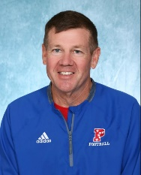

Milton Kelly Gillis George Blake
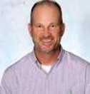
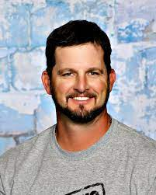

Escambia Mike Bennett
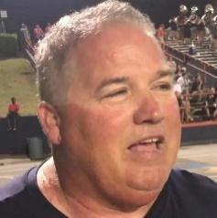

Tate Rhett Summerford Greg Blackmon
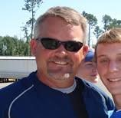
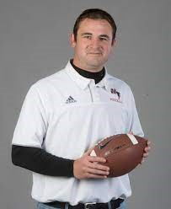

Okaloosa Middle Schools

Bruner Seagar

Meigs Josh Riggins

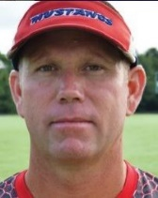
Shoal River Ryan Gillis

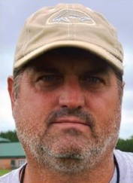
Davidson Chris Small

Ruckel Ron Reece

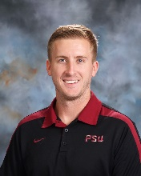
Pryor Justin Savage

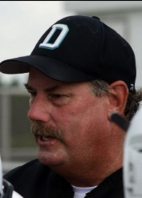
Destin Mark Hinterthen

Lewis Joseph Pearson
