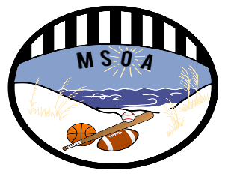 MSOA List of Fouls 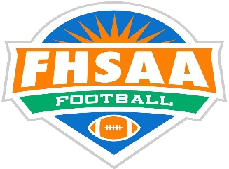
COMMON FOULS
Delay of Game | DOG |  | Illegal Forward Pass | IFP
Encroachment | ENC |  | Intentional Grounding | ING
False Start | FST |  | Illegal Motion | ILM
Free Kick Out of Bounds | KOB |  | Illegal Shift | ISH
Illegal Formation | ILF |  | Illegal Substitution | ILS
Illegal Touching | ILT |  | Illegal Participation | ILP

OTHER FOULS |  |  | PERSONAL FOULS
Fighting | FIT |  | Blindside Block | BSB
Holding - Offense | OH |  | Blocking Below the Waist | BBW
Holding - Defense | DH |  | Chop Block | CHP
Illegal Batting | BAT |  | Clipping | CLP
Illegal Block in Back | IBB |  | Disqualification | DSQ
Illegal helmet Contact | ILH |  | Face Mask Holding - 5 | FM5
Illegal Kicking Ball | KIK |  | Face Mask Grabbing – 15 | FM15
Illegal Kicking | IKB |  | Horse Collar Tackle | HCT
Ineligible Player Downfield | IDP |  | Hurdling | HUR
Interlocking Blocking | INL |  | Illegal Contact on Snapper | ICS
Kick Catch Interference | KCI |  | Illegal Crackback | ICB
Pass interference – OFF | OPI |  | Late Hit / Piling On | LTP
Pass Interference – DEF | DPI |  | Roughing Kicker / Holder | RRK
Running into Kicker/ Holder | RNH |  | Roughing Passer | RPS
Sideline Interreference | SLI |  | Tripping | TRP
Unsportsmanlike | UNS |  | Unnecessary Roughness | UNR

